**San Francisco Bay University**

**MATH201 - Calculus-I**

**Homework Assignment #2**

**Due day: 6/10/2023**

**Instruction:**

1. **Push the answer sheet to Github in word file**
2. **Overdue homework submission could not be accepted.**
3. **Takes academic honesty and integrity seriously (Zero Tolerance of Cheating & Plagiarism)**
4. **Plot each following group of functions in one graph respectively by Excel, covering the appropriate domain of *x* and *y.***

1. **Given , prove that and verify it by the plot in Excel.**

Thus, we have proved that .

1. **Compare the functions and by plotting curve in Excel and which function grows more rapidly when *x* is large? And prove it mathematically.**

To prove it mathematically, we can compare the limits of the functions as x approaches infinity.

For

For

Both functions have limits that approach infinity as x goes to infinity. However, since the exponential function g(x) = grows at an exponential rate, it grows more rapidly than the polynomial function when x is larger.

Hence, mathematically and graphically, we can conclude that grows more rapidly than when x is larger.

1. **Plot the function in Excel. And then prove that is an odd function.**

We can prove that f(-x) = -f(x) for all values of x mathematically:

Let’s substitute -x into the function to find f(-x):

We will simplify the expression for f(-x):

Since f(-x) = -f(x) for all values of x, we have proven that is an odd function.

1. **For the parametrized function** 
   1. **where a > 0. How does the graph change when b changes by showing a group of curves by Excel?**

Graph when b mostly have positive values.

Graph when b mostly have negative values.

* 1. How does it change when *a* changes in **Excel**?

Graph when a changes.

Graph when a < 0:

We notice that by varying the “a” value and updating the graphs accordingly, we can see the different values of “a” affecting the scaling of the graph.

1. **If , find expression. And that, plot and in one graph by Excel**

Let us solve the equation for y:

Plotting

**Plotting y = g**

**Plotting y = x**

Plotting

1. **When a camera flash goes off, the batteries immediately begin to recharge the flash’s capacitor, which stores electric charge given by**

**(The maximum charge capacity is and t is measured in seconds.)**

* 1. **Find the inverse of this function and explain its meaning.**

We will replace Q(t) with y:

Now, we will swap the positions of y and t:

We will now solve for y to find the inverse function:

.

The Inverse function represents the time it takes to reach a certain charge level t, given the maximum charge capacity of and the charging rate parameter a. Meaning, if we know how much charge we want to achieve (t), we can use the inverse function to determine how much time (y) it will take to reach that charge level.

**How long does it take to recharge the capacitor to 90% of capacity if a = 2 showing in the plot by Excel?**

If we want to calculate how long it takes to recharge the capacitor to 90% of capacity ( when , we can substitute these values into the inverse function as below:

)

1. **Graph when**  **values change:**

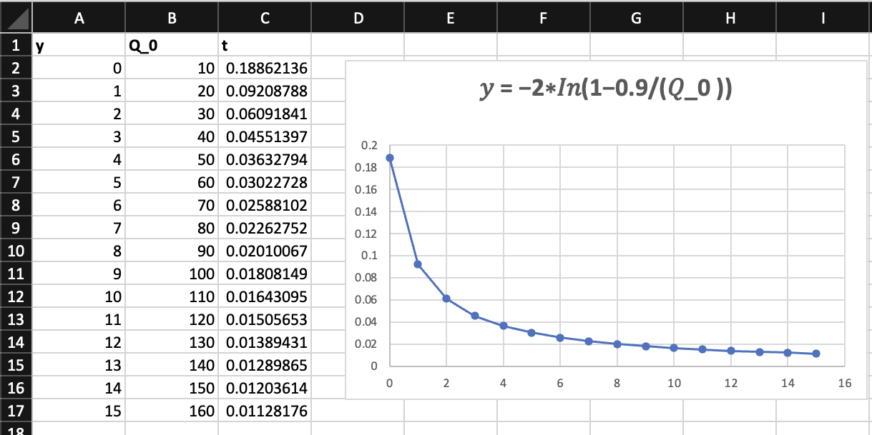

1. **Graph when**  **value is constant:**

